GenICam browser usage

|  |  |
| --- | --- |
| Abstract | This documents explains how to use GenICam browser |
| Version | 0.1 |
| Status | Draft |
| Date | 2020/06/25 |
|  |  |
|  |  |
|  |  |

Table of contents

1 Introduction 2

2 Check Version 2

2.1 Launch GenICam Browser 2

2.2 Help > About 3

2.3 Tools > Start Firmware Manager 4

2.4 Firmware revision 5

3 Check Camera 6

3.1 Reset the camera 6

3.2 Configure the camera 9

# Introduction

Check FrameGrabber firmware version is correctly setup  
Check the camera is operational

# Check Version

## Launch GenICam Browser

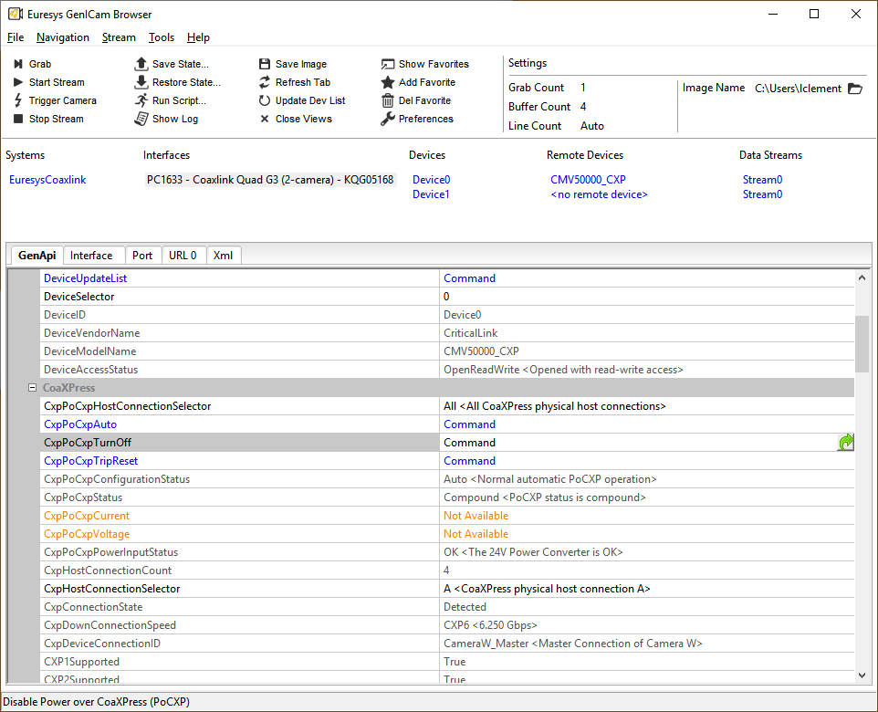

## Help > About

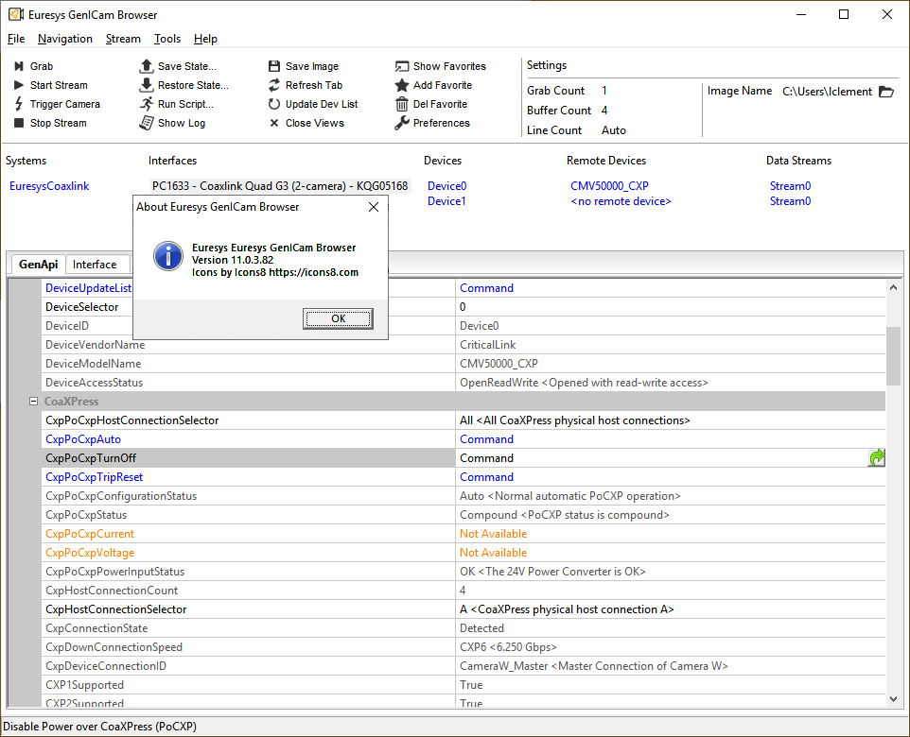

Check version is 11.0.3

## Tools > Start Firmware Manager

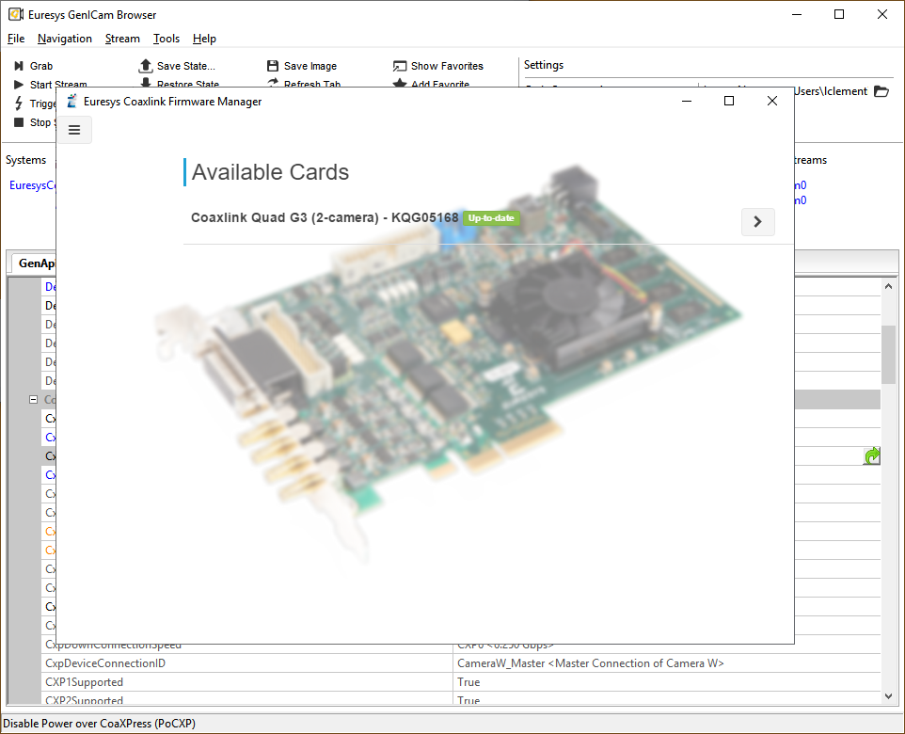

Check installed firmware is CoaxlinkQuad G3 (2 camera)

## Firmware revision

Press >

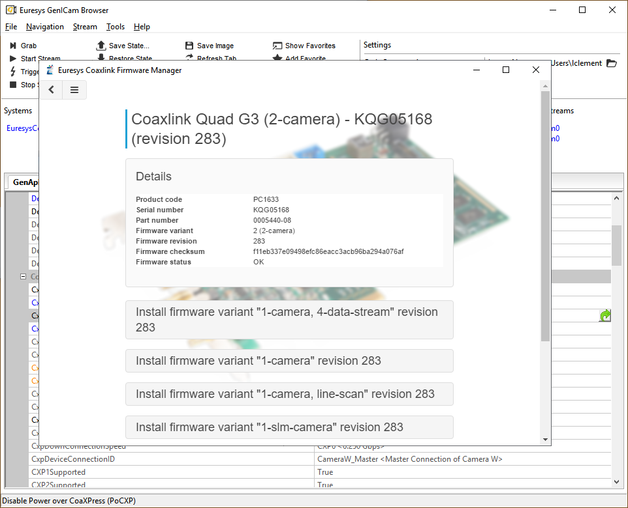

Check the revision of the firmware

# Check Camera

## Reset the camera

In **Interfaces** section, execute command **CxpPoCxpTurnOff.**The Taprisiot should turn off.

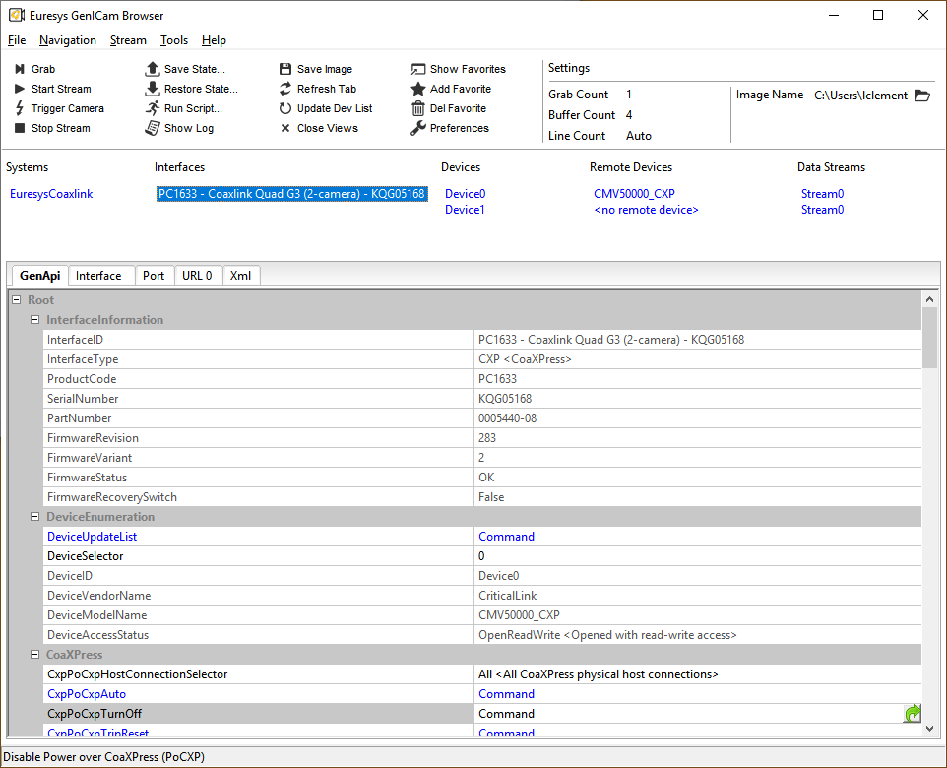

Press **Update Dev List** button: CMV50000_CXP disappears from **Remote Devices** section

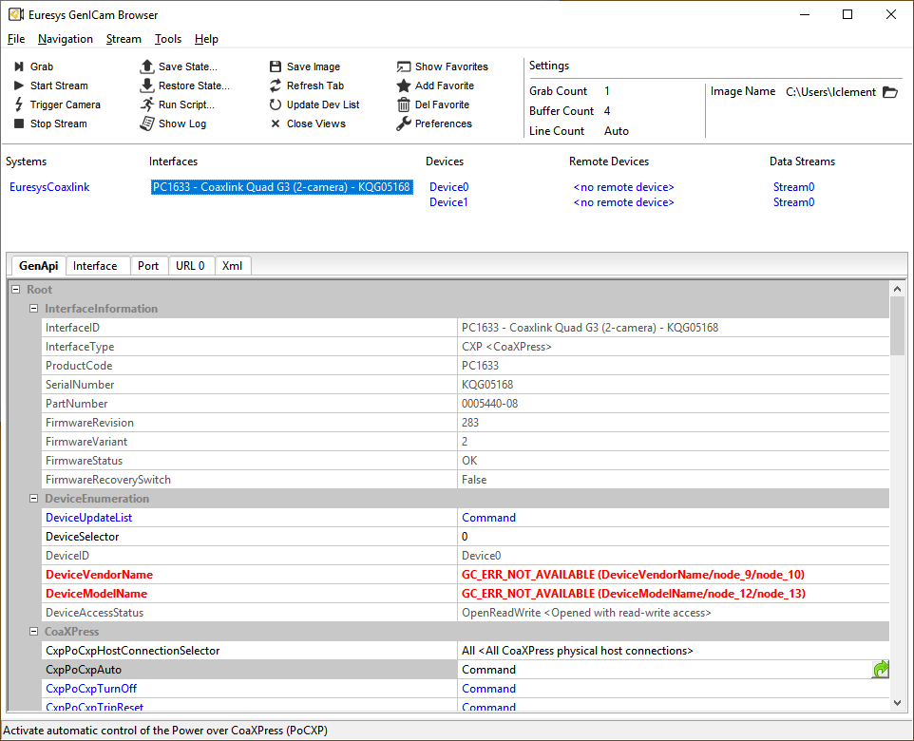

In **Interfaces** section, execute command **CxpPoCxpAuto** to restart the camera.  
It takes few seconds for the camera to start-up.  
Press **Update Dev List** button; the camera is ready when it appears in Remote Devices.



## Configure the camera

Set DeviceStreamChannelPacketSize to 4096

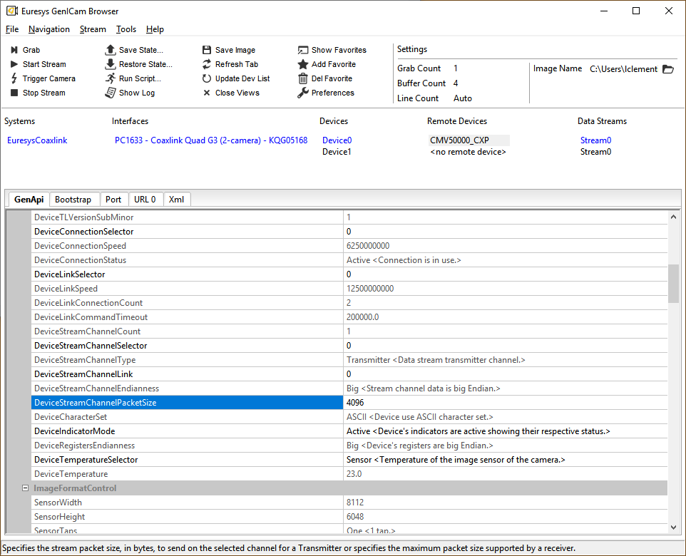

Set AcquisitionFrameRate to 10

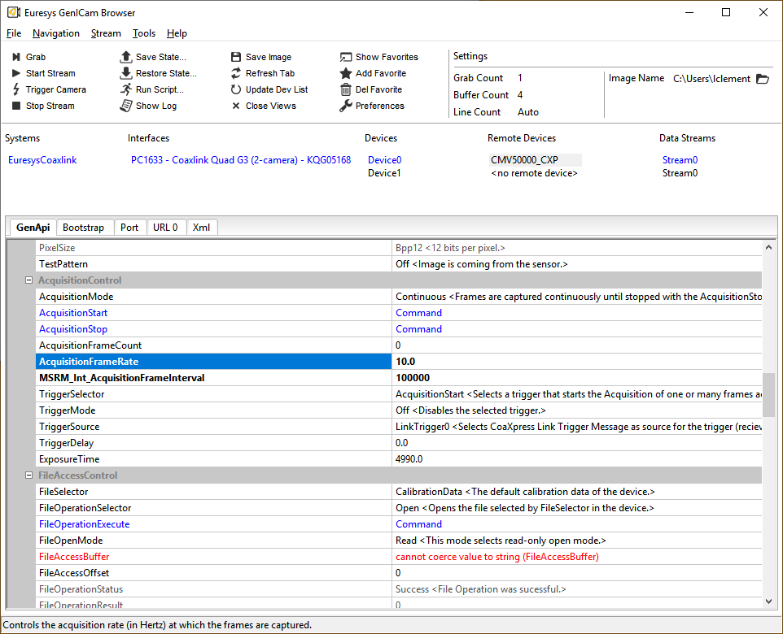

Set ExposureTime (in us).

Press Grab or Start Stream button.

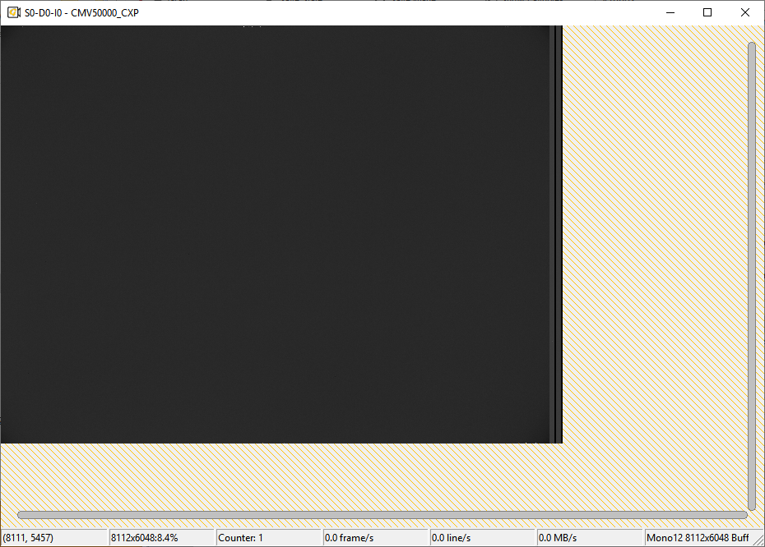

In case of stream, frame counter will increase.

